GIT 

* Git is a [free and open source](https://git-scm.com/about/free-and-open-source) distributed version control system designed to handle everything from small to very large projects with speed and efficiency
* Git is  [easy to learn](https://git-scm.com/doc) and has a [tiny footprint with lightning fast performance](https://git-scm.com/about/small-and-fast).
* The Git feature that really makes it stand apart from nearly every other SCM (Source Code Management ) out there is its branching model.

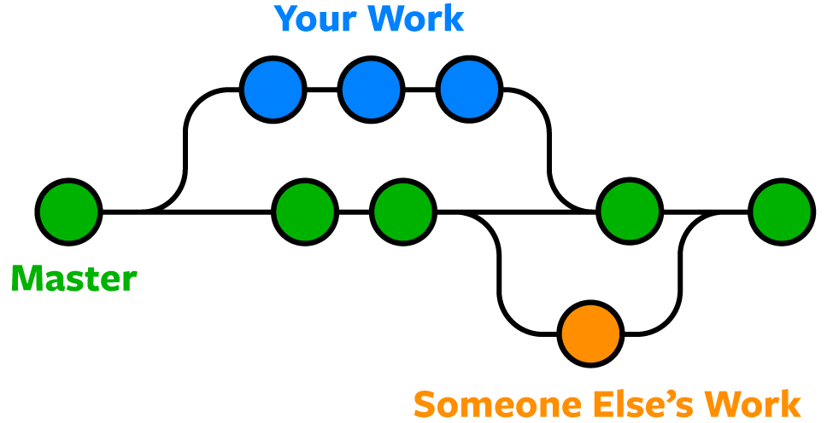

* Working of git – local to remote

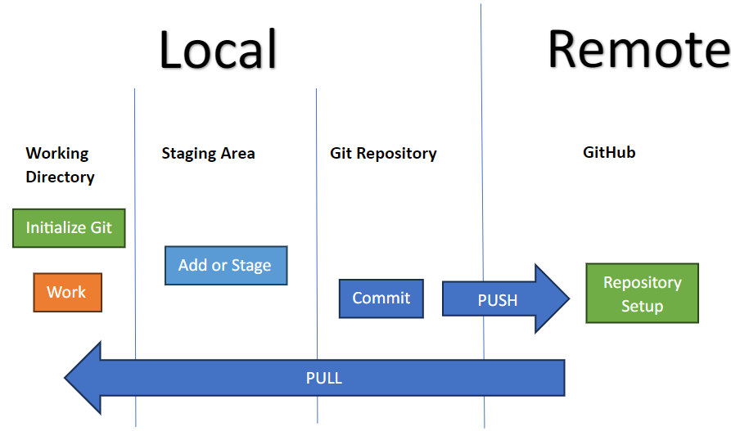

* From remote to local- revert it

